
Contact

Send you Cv’s to job@mazco.com.sa

Or

Post Box: 2486, Dammam 31451,
KINGDOM OF SAUDI ARABIA.
Tell: +966 3 8260080 EXT: 31
Fax : +966 3 8266618
Website::www.mazco.com.sa

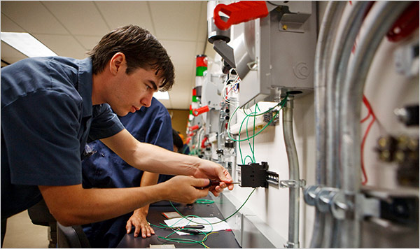
JOB DESCRIPTION
Electrical technician shall
- Work with electrical system operation & maintenance (switchgears UPS, DC chargers, breakers. transformers, motors, CP, electrical control system. Light system, etc.
- Thorough understanding with practical experience in Implementation of techniques used in maintenance.
- Read the electrical drawings and its legend.
- Perform PM/CM activities.
- Use all measurements and testing tools.
- Applying electrical system troubleshooting/Tracing.
- Provide accurate written electrical technical reports.
- Doing any electrical Job as per technical instruction
- Perform all kinds of electrical Jobs within safely manner.

QUALIFICATION
- Diploma in Electrical Engineering
- Minimum experience of 5 years in the field
- Good communication skill
- Awareness of safety rules
- Analytical skill and organizational commitment

Electrical technician

